1. 
2. 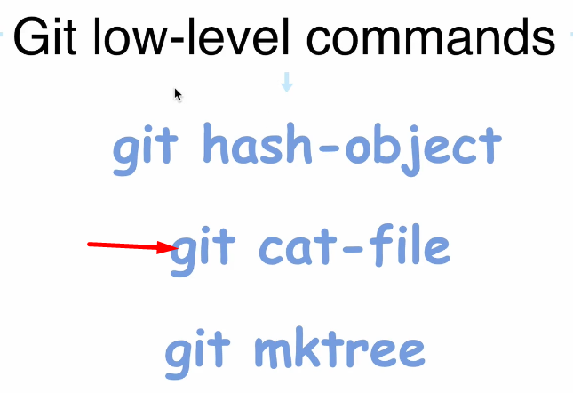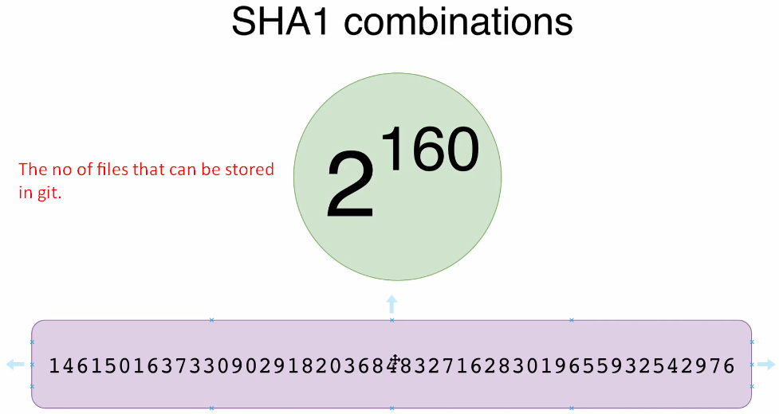  
   **NOTE**: As 2 ^ 160 is the total numbers of different hash code and each file has a unique hash code.
3. 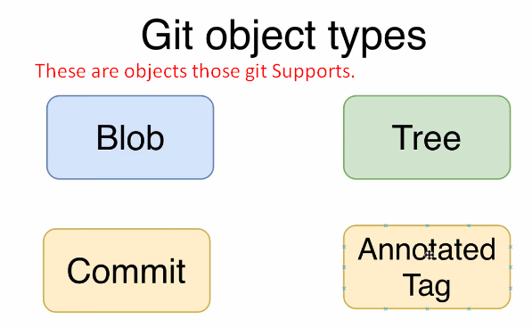
4. 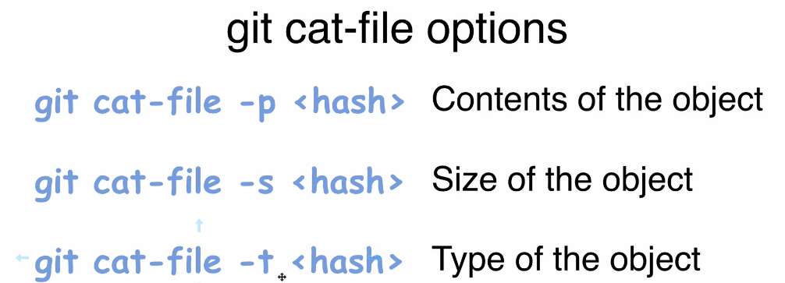
5. 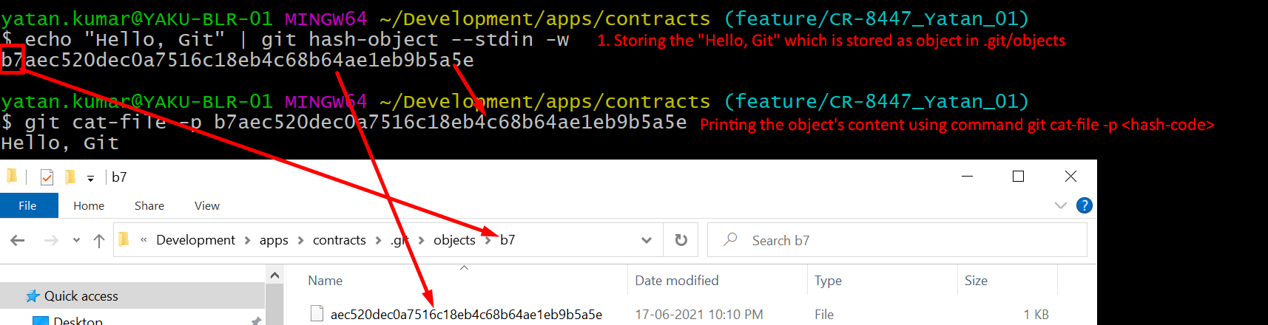
6. 
7. 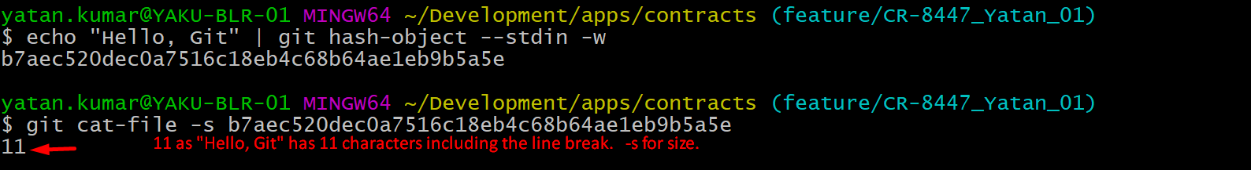
8. 